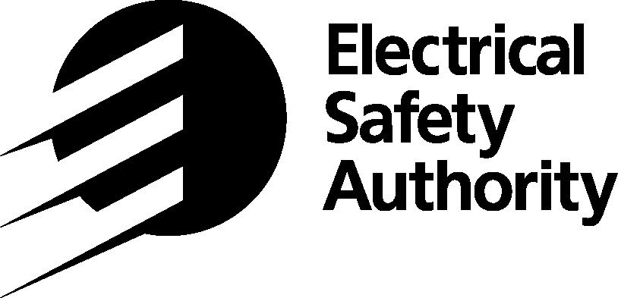
ONTARIO PROVINCIAL REQUIREMENTS FOR
EXHIBITING ELECTRICAL EQUIPMENT
AT TRADE SHOWS

The Ontario Electrical Safety Code (Ontario Regulation 10/02) is the provincial regulation that defines the minimum requirements for electrical installations and electrical products in Ontario. The Electrical Safety Authority is responsible for enforcement of the Ontario Electrical Safety Code.

Rule 2-022 of the Ontario Electrical Safety Code requires that any electrical equipment that is being displayed, offered for sale, or used in any show/convention/or similar exhibition SHALL BE APPROVED. At Trade or Consumer shows, unapproved electrical equipment will only be permitted to be displayed (not energized) when the Electrical Safety Authority gives permission through the Permission to Show. Failure to comply with the Ontario Electrical Safety Code could result in charges under the Electricity Act.

Electrical equipment is considered approved if it bears the certification mark or Field Evaluation label of an organization that has been accredited by the Standards Council of Canada to approve electrical equipment. If these markings are missing, the equipment is considered to be unapproved. Bulletin 2-7-* (*indicates latest version) shows all approved certification marks or Field Evaluation markings accepted in Ontario. Since markings are updated regularly visit our web site at www.esasafe.com (electrical product safety section) for a current listing.

Note - Electrical equipment shall be approved as an assembled unit. The exhibitor is expected to make every reasonable effort to have electrical equipment approved prior to the show.

Permission to Show:
Exhibitors with unapproved electrical equipment that wish to display but not to connect or provide electricity to the equipment, must complete the Permission to Show Notification and pay the fee indicated for unapproved electrical equipment that will be displayed but not energized. Exhibitors will be provided with a sales receipt which must be available to inspectors on show site at all times.

The “Permission to show” Notification does not permit the connection/energization of unapproved electrical equipment.

Permission to Energize – Trade Shows only:
Exhibitors that wish to connect and energize (provide electricity to) unapproved electrical equipment, must complete the Permission to Energize Notification and pay the Permission to Energize fee indicated for each piece of unapproved electrical equipment. Exhibitors are not required to complete the Permission to Show Notification for the same piece of equipment. The following conditions apply:

- If no imminent hazards are present, ESA will permit the equipment to be energized “for demonstration purposes only”.

- A sign/notice will be affixed to the equipment (prominently displayed) indicating “This equipment is not approved for sale in Ontario and is “Energized for demonstration purposes only”. Our ESA Inspectors will provide exhibitors with this notice.

- The “Permission to Energize” is only valid for the duration of the show, and cannot be carried forward or extended for subsequent shows in other cities.

- The “Permission to Energize” notification allows the equipment to be wired to an available junction box or disconnect as provided by the on-site electrical contractor.

- “Permission to Energize” is available for Trade shows only, not Consumer shows.

PERMISSION TO SHOW NOTIFICATION

This notification does not permit the connection/energization
of unapproved electrical equipment

Please send your completed notification with payment information to:

Mail to: Electrical Safety Authority
Email: esa.cambridge@electricalsafety.on.ca 400 Sheldon Drive, Unit 1
Cambridge, Ontario N1T 2H9
For more information call: 1 (877) ESA-SAFE (372-7233)

ESA Account #: Date:

Payment Method
 |  | Credit Card
 | Charge to ESA Account | ESA Account customer – provide the last 4 digits of the card saved on file with ESA
 |  | Non-account customer – DO NOT submit this form to pay by credit card.
 |  | To comply with Credit Card Payment security requirements, an ESA representative will contact you during regular business hours Mon-Fri 7:00AM-4:30PM to process your credit card payment. Please DO NOT include any credit card information on this form.

The fee is $69 + $8.97 HST = $77.97 per booth

Please provide the following information
COMPANY INFORMATION
COMPANY NAME: |  |  |  |  |  |  |  |  |  |  |  |  |  |  | ATTENTION:
MAILING ADDRESS:
CITY: |  |  |  |  |  |  |  |  |  |  |  |  |  | PROVINCE:
POSTAL/ZIP: |  |  |  |  |  |  |  |  |  |  |  |  |  | COUNTRY:
PHONE: |  |  |  |  |  |  |  |  |  |  |  |  |  | FAX:
SHOW INFORMATION
NAME OF SHOW:
SHOW LOCATION:
ADDRESS:
SHOW DATES: |  |  |  |  |  | Starting: |  |  |  |  |  |  |  |  |  |  | Ending:
BOOTH #: |  |  |  |  |  |  |  |  |  |  | CONTACT AT SHOW:
CONTACT cell #: |  |  |  |  |  |  |  |  |  |  |  | CONTACT email:
LIST OF UNAPPROVED ELECTRICAL EQUIPMENT TO BE SHOWN
Quantity |  |  |  | Manufacturer |  |  |  |  |  |  |  |  | Description |  |  |  |  |  |  |  | Model

By submitting personal information to the Electrical Safety Authority, or its agents and service providers, you agree that ESA may collect, use and disclose such personal information in accordance with its privacy policy, applicable laws or pursuant to our administrative agreement with the Province of Ontario. If you provide us with the personal information on behalf of another individual, you represent that you have all necessary authority and/or have obtained all necessary consents from such individual to enable us to collect, use and disclose such personal information for the purposes set forth in our Privacy Policy. A copy of our policy is located on our website at www.esasafe.com

PERMISSION TO ENERGIZE NOTIFICATION
TRADE SHOW ONLY
(Not Applicable to Consumer Shows)

Please send your completed notification with payment information to:

Mail to: Electrical Safety Authority
Email: esa.cambridge@electricalsafety.on.ca 400 Sheldon Drive, Unit 1
Cambridge, Ontario N1T 2H9
For more information call: 1 (877) ESA-SAFE (372-7233)

ESA Account #: Date:

Payment Method
 |  | Credit Card
 | Charge to ESA Account | ESA Account customer – provide the last 4 digits of the card saved on file with ESA
 |  | Non-account customer – DO NOT submit this form to pay by credit card.
 |  | To comply with Credit Card Payment security requirements, an ESA representative will contact you during regular business hours Mon-Fri 7:00AM-4:30PM to process your credit card payment. Please DO NOT include any credit card information on this form.

The fee is $162 + $21.06 HST = $183.06 per item of equipment

Please provide the following information:
COMPANY INFORMATION
COMPANY NAME: |  |  |  |  |  |  |  |  |  |  |  |  |  |  |  |  | ATTENTION:
MAILING ADDRESS:
CITY: |  |  |  |  |  |  |  |  |  |  |  |  |  |  |  | PROVINCE:
POSTAL/ZIP: |  |  |  |  |  |  |  |  |  |  |  |  |  |  |  | COUNTRY:
PHONE: |  |  |  |  |  |  |  |  |  |  |  |  |  |  |  | FAX:
TRADE SHOW INFORMATION
NAME OF SHOW:
SHOW LOCATION:
ADDRESS:
SHOW DATES: |  |  |  |  |  |  | Starting: |  |  |  |  |  |  |  |  |  |  |  | Ending:
BOOTH #: |  |  |  |  |  |  |  |  |  |  |  |  | CONTACT AT SHOW:
CONTACT cell #: |  |  |  |  |  |  |  |  |  |  |  |  |  | CONTACT email:
LIST OF UNAPPROVED ELECTRICAL EQUIPMENT TO BE ENERGIZED
Quantity |  |  |  |  | Manufacturer |  |  |  |  |  |  |  |  |  | Description |  |  |  |  |  |  | Model

By submitting personal information to the Electrical Safety Authority, or its agents and service providers, you agree that ESA may collect, use and disclose such personal information in accordance with its privacy policy, applicable laws or pursuant to our administrative agreement with the Province of Ontario. If you provide us with the personal information on behalf of another individual, you represent that you have all necessary authority and/or have obtained all necessary consents from such individual to enable us to collect, use and disclose such personal information for the purposes set forth in our Privacy Policy. A copy of our policy is located on our website at www.esasafe.com

